1. Open u-center 22.07

1. Power the Qantum V1 through PCIe with a host and connect the back micro-USB port to your computer running u-center. You should see the two green LEDs on the Time Card, meaning the Time Card power is working.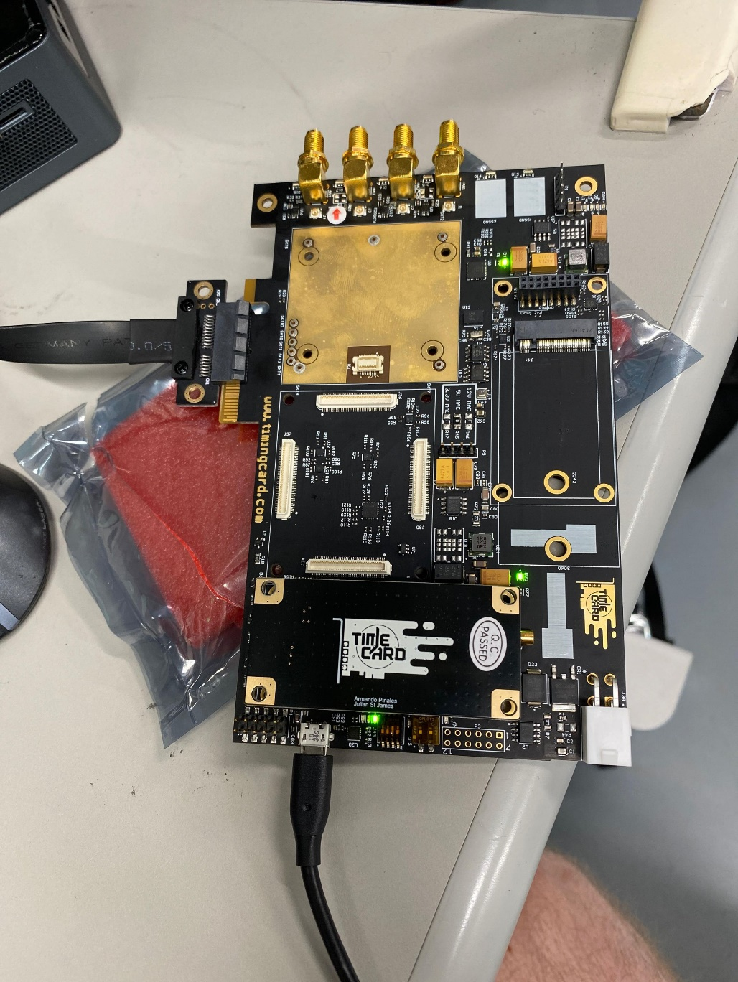
2. Select the COM port that shows up in U-center under Receiver -> Connection, for example COM25. It will display that at the top of U-center window.

1. Flip these two DIP switches so D21 and D12 are lit

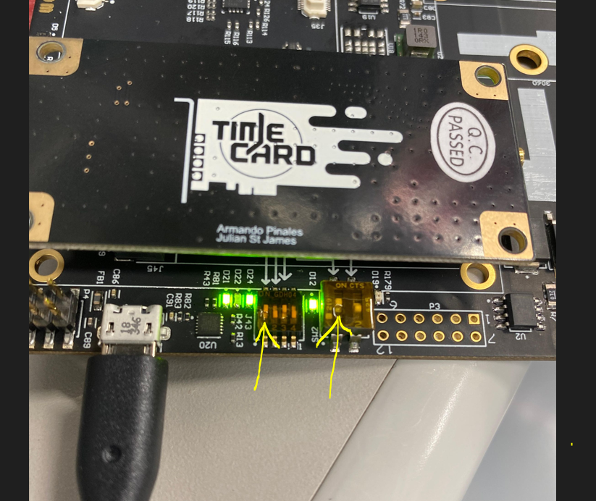

1. In u-center, the default baud rate for the NEO-M9N is 38400. It should auto detect, but you can manually set it in Receiver -> Baud rate -> 38400. This will show at the top of u-center.

1. Verify the connection is made. In u-center, go to view -> Binary console. A window in u-center should pop up, and you should see messages from the NEO-M9N, like this

1. Go under Tools -> Receiver configuration in u-center, a new window will pop up.

1. Select the NEO-M9N configuration file timingCardUBXM9_PPS_115200_Monitor.txt that is part of the github repo for the Time card, located here: https://github.com/opencomputeproject/Time-Appliance-Project/tree/master/Time-Card/GNSS/UBlox/NEO-M9N/Configs/NEO-M9N-00B-00

1. Press Transfer file -> GNSS

1. U-center should auto-update the baud rate from 38400 to 115200 by the end of the programming procedure. If not, manually change the baud rate under Receiver -> Baudrate to 115200

1. Go through the procedure to Transfer File -> GNSS one more time, to make sure all the configuration went through, steps 7-9. This is because the baud rate change may interfere with some configuration parameters.
2. To save the configuration persistently, go under Receiver -> Action -> Save Config. Run that twice, again to make sure it’s done.
3. After completed, please flip the two DIP switches back to allow for normal operation with the FPGA on the Time Card for GNSS2, so D21 and D12 LEDs on the board are off